*G.O.T.R. helps to instill the importance of physical activity and*



*healthy lifestyle choices*

**The mission** isto educate and prepare girls for a life-time of self-respect and healthy living through a 10-week program which combines self-esteem enhancing life-lessons , discussions, and running games in an encouraging, girl-positive environment where girls can feel free to express themselves and build their confidence.

**The goal** is to empower girls early in their lives to find strength, courage and self-respect from within, and draw upon these as they face the challenges of adolescence and adulthood.

**GIRLS ON THE RUN SANTA FE HAS BEEN INCORPORATED SINCE NOVEMBER 2006. TO DATE WE HAVE SERVED OVER 830 GIRLS AGES 8-13 YEARS AT FIVE DIFFERENT ELEMENTARY SCHOOLS. OUR FOCUS IS ON TITLE I SCHOOLS. WE ARE A 100% VOLUNTEER ORGANIZATION. ALL FUNDS RAISED GO DIRECTLY TO PROGRAM COSTS.**

**Girls who are physically active gain** a higher level of self-confidence, self-esteem and self-image and have lower risks of developing depression and anxiety disorders. They also have higher grade point averages, better SAT scores, and a lower risk of dropping out of school. They have shown decreased risks of eating disorders, smoking, alcohol use, sexual behavior and pregnancy,

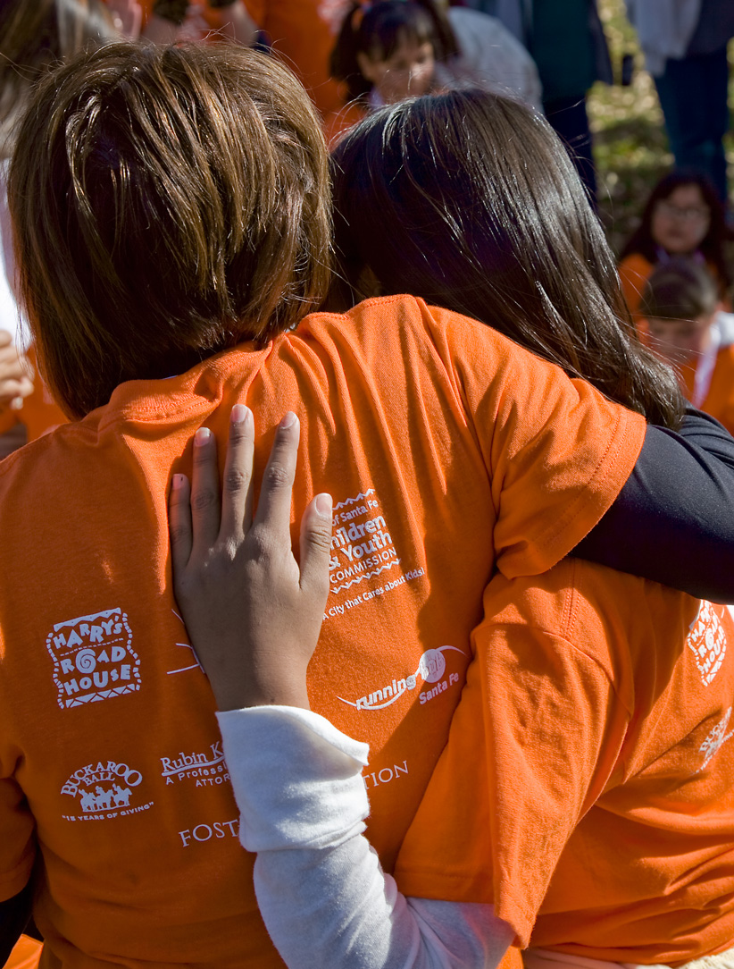

**Girls on the Run Santa Fe**  
**(505)** **660-2972**[www.girlsontherun.org](http://www.girlsontherun.org/)

www.gotr-sf.org